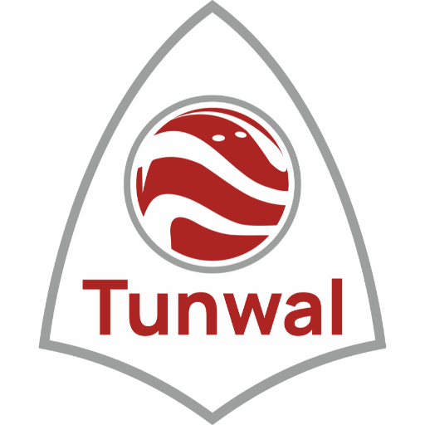

RISK MANAGEMENT POLICY

FRAMEWORK:

Risk management policy and processes will enable the Company to proactively manage uncertainty and changes in the internal and external environment to limit negative impacts and capitalize on opportunities.

The Company’s Risk Management Policy (“the Policy”) outlines the program implemented by the
Company to ensure appropriate risk management within its systems and culture.

The Policy is formulated in compliance with Regulation 17(9)(b) of SEBI (Listing Obligations and Disclosure Requirements) Regulations, 2015 (“the Listing Regulations”) and provisions of the
Companies Act, 2013 (“the Act”), which requires the Company to lay down procedures about risk
Assessment and risk minimization.

OBJECTIVE & PURPOSE OF POLICY:

- The main objective of this policy is to ensure sustainable business growth with stability and to promote a pro-active approach in reporting, evaluating and resolving risks associated with the business. In order to achieve the key objective, the policy establishes a structured and disciplined approach to Risk Management, in order to guide decisions on risk related issues. The specific objectives of the Risk Management Policy are:
- To ensure that all the current and future material risk exposures of the company are identified, assessed, quantified, appropriately mitigated, minimized and managed i.e. to ensure adequate systems for risk management.
- To establish a framework for the company’s risk management process and to ensure its
implementation.
- To enable compliance with appropriate regulations, wherever applicable, through the adoption of best practices.
- To assure business growth with financial stability.

OVERSIGHT AND MANAGEMENT:

Board of Directors The Board of Directors (“the Board”) is responsible for reviewing and ratifying the risk management structure, processes and guidelines which are developed and maintained by Committees and Senior Management. The Committees or Management may also refer particular issues to the Board for final consideration and direction.

Risk Management Committee:

The day to day oversight and management of the Company’s risk management program has been conferred upon the Committee. The Committee is responsible for ensuring that the Company maintains effective risk management and internal control systems and processes, and provides regular reports to the Board of Directors on the effectiveness of the risk management program in identifying and addressing material business risks. To achieve this, the Committee is responsible for:

- Managing and monitoring the implementation of action plans developed to address material business risks within the Company and its business units, and regularly reviewing the progress of action plans;
- setting up internal processes and systems to control the implementation of action plans;
- Regularly monitoring and evaluating the performance of management in managing risk.
- Providing management and employees with the necessary tools and resources to identify and manage risks;
- Regularly reviewing and updating the current list of material business risks;
- Regularly reporting to the Board on the status of material business risks;
- Review and monitor cyber security; and
- Ensuring compliance with regulatory requirements and best practices with respect to risk management.

Further, the Company is exposed to commodity risks on a routine basis due to multiple commodities (imported or domestically procured) utilized in its manufacturing operations. Such risks are managed by a detailed and regular review at a senior level of various factors that influence the commodity prices as well as tracking the commodity prices on a daily basis and entering into fixed price contracts with overseas suppliers in order to hedge price volatility.

Senior Management

The Company’s Senior Management is responsible for designing and implementing risk management and internal control systems which identify material risks for the Company and aim to provide the Company with warnings of risks before they escalate. Senior Management must implement the action plans developed to address material business risks across the Company and individual business units.

Senior Management should regularly monitor and evaluate the effectiveness of the action plans and the performance of employees in implementing the action plans, as appropriate. In addition, Senior Management should promote and monitor the culture of risk management within the Company and compliance with the internal risk control systems and processes by employees. Senior Management should report regularly to the Risk Management Committee regarding the status and effectiveness of the risk management program.

Employees

All employees are responsible for implementing, managing and monitoring action plans with respect to material business risks, as appropriate.

DISCLOSURE IN BOARD’S REPORT:

Board of Directors shall include a statement indicating development and implementation of a risk management policy for the company including identification therein of elements of risk, if any, which in the opinion of the Board may threaten the existence of the company.

AMENDMENT:

Any change in the Policy shall be approved by the Board of Directors or any of its Committees (as may be authorized by the Board of Directors in this regard). The Board of Directors or any of its authorized Committees shall have the right to withdraw and / or amend any part of this Policy or the entire Policy, at any time, as it deems fit, or from time to time, and the decision of the Board or its Committee in this respect shall be final and binding. Any subsequent amendment / modification in the Listing Regulations and / or any other laws in this regard shall automatically apply to this Policy.

*******************

